May 12, 2026

Dear Parents/Caregivers:

The 2026 – 27 School Calendar is attached for your information. Please find below the specific school information
for École Poirier Elementary School for the 2026 -27 school year.

School Operation Details By Day for 2026 - 27:

- Length of School Day: 8:50 a.m. – 2:40 p.m.

2. School Office Hours: 8:00 a.m. – 3:30 p.m.

- Hours of instruction in a school week: 24 hours/ 25 minutes

- Minimum Hours of Instruction Per Year: School Calendar Regulation (BC Reg.) 314/12-K – 853 hrs./yr; Gr. 1-7 – 878 hrs./yr;

- Number of Breaks: one 15 minute recess/break. Time: 10:20 a.m. – 10:35 a.m.

- Lunch Break: 12:05 p.m. – 12:47 p.m.

- Early Dismissal (Three Hours for All Schools) – Parent-Teacher Interviews/Conferences:
- Thurs., Nov. 26
- Fri., Apr. 16, 2027

*8. Only for schools with Kindergarten:
The first regular day for Kindergarten students will be Wednesday, Sept. 16, 2026, with orientation and small group sessions scheduled for September 10, 11, 14 and 15, 2026. Details of this schedule will be communicated by the school.

Should you have any questions about the School Calendar or operational details, please contact your school Principal.

Yours respectfully,
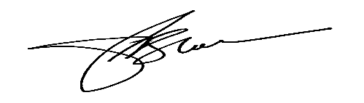
Paul Block
Superintendent of Schools

attachments

