École Poirier Elementary School
May 4th to 8th , 2026 “THE BEAR”



Monday – May 4th | - Whole School Assembly 10:40pm (gym)  - Student Run Art Club – 12:05pm at the front of the school during lunch recess outside.
Tuesday – May 5th | - Pride Club Mme Deshane's class: Grades 4/5  - Track Practice – Grade 4/5 distance runners @ 12:05pm, & shot put @ 10:20am (short recess)  - Red Dress Day  - PAC Meeting – 7PM please join online
Wednesday- May 6th | - Lego Club – recess 10:20am (grades K to 1/2 split)  - Choir Practice – 12:05pm in the Music Room  - Track Practice - Grade 5 Relays - Group #1 @ 12:05pm
Thursday – May 7th | - Lego Club – recess 10:20am (grades 2/3 split to 4)  - Track Practice – Grade 4 Relays @ 12:05pm  - Student Run Art Club – 12:05pm at the front of the school during lunch recess outside.
Friday – May 8th | - Dance Club 12:05pm in the gym  - Track Practice – Grade 5 Relays - Group #2 @ 12:05pm

This Week: Upcoming Events:
May
11 Pro D - Non-Instructional Day – No School
12 Performance (Will’s Jam)– 1:00pm
15 FIRE Drill @ 10:10am
15 Grade 5 Talent Show video submissions due (first deadline)
15 Choir visit to Ayre Manor- 12:30 to 2:15pm
18 Victoria Day – No School
20 Walk-A-Thon – 1:30pm
22 Welcome to Kindergarten – 2026 new kindies
25 Whole School Assembly 10:40pm (gym)
26 Public Board Meeting - 7:00pm
29 Sooke Elem. Track & Field Event at EMCS
June
2 PAC Meeting – 7PM please join online
3 Grade 5 Talent Show Dress Rehearsal in the gym starting at 1:15. All stage and video participants will attend. Closed to guests.
4 Grade 5 Talent Show Day! 1:15 – 2:15 in the gym. Families are welcome to attend!
8 Whole School Assembly 10:40pm (gym)
12 Indigenous Day Celebrations – school event – all day
17-19 Grade 4/5 Camp Thunderbird
21 National Indigenous Day
22 Whole School Assembly 10:40pm (gym)
22 Fun Day – with sprinklers etc in the PM
22 Fun Fair – PAC Event 5:00 to 7:00
23 Beach Day – French Beach
23 Public Board Meeting - 7:00pm
25 Last Day of school for students!

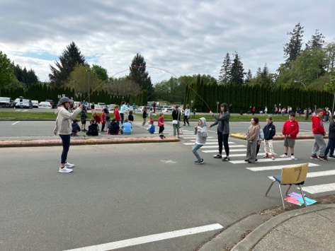
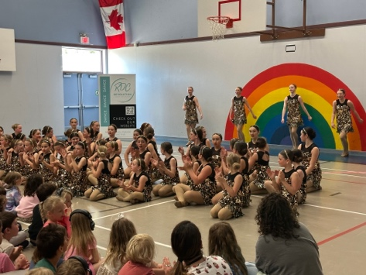

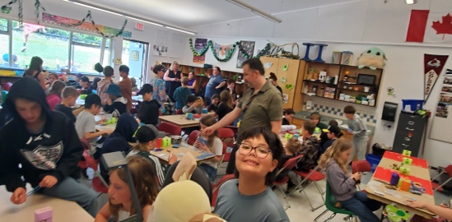
JUMP ROPE for HEART was absolutely fun! Thank you to the organizers and all the volunteers who made this event happen. Thank you everyone!
Dance Revolution came to École Poirier to perform for everyone. There were current Poirier students in attendance as well as many past Poirier bears. Fun was had by all! Thank you for coming out to dance! Beautifully entertaining!

École Poirier Walk-A-Thon
🚶‍♂️🎉 Lace up those sneakers, Poirier Black Bears… it’s almost time! 🎉🚶‍♀️
Get ready to walk, cheer, and groove your way through one of our favourite fundraisers of the year — the École Poirier Walk-A-Thon is happening on Wednesday, May 20 at 1:30 PM.
🎽 It’s not just a walk — it’s a full-on celebration of school spirit, movement, and community.
💌 Pledge forms will be heading home this week — don’t lose them in your backpack jungle!
📅 All forms and donations are due back by Monday, May 25th.
Let’s rally together, raise some funds, and have a blast while doing it. Every step supports our school — and every smile makes it more special 💙

Perfect Order Pokemon Tournament
Fun was had by all who played. Thank you to Mr. Thompson and Mme Dupius for organizing this fun event,

Read & Ride was a huge success. Thirty-five new famiies showed up today with their children. Fun was had by all! Thank you to Mme Tiringer and Ms. Marie for organing this event.
